MedCommons

HIPAA-Compliant Router

System-Level Description

V 0.5
February 18, 2004

This is a compound document that organizes a number of block diagrams and tables (file names are listed below) to provide different perspectives on the MedCommons system. The Actor perspective describes interaction with screens generated by the MedCommons system. The System Configurations diagram shows different options for image capture and image viewing from a hardware and facilities perspective. The System Diagram and corresponding Module Table describe the system as 30 hardware / software modules - separated between the Router and the Central Facilities – that combine to generate the user interface screens. An abstract screen shot of the key Selection Screen is provided. Finally, a logical perspective on the MedCommons system is described using a data flow model that bridges between the institutional control and patient control viewpoints.

Contents:

Actors and their Actions (this .doc)

System Configurations.vsd

System Diagram4.vsd

C:\MacLaren\Central\ISO_and_FDA\Medical Router PB3\System Diagram4-1.gif

C:\MacLaren\Central\ISO_and_FDA\Medical Router PB3\System Diagram4-2.gif

Module Table.xls

Selection Screen.ppt

Router Data Flow.xls

CONFIDENTIAL

Actors and their Actions

1 - Patient
a - Patient Registers at Referring Physician Office > Step 2
b - Patient Registers at Imaging Center > skip to Step 5
c - Patient has old registration or Registers at Home using MedCommons Central Facilities > Step 5

2 - Referring Physician
a - Referring Physician Orders Test

3 - Referring Physician’s Clerk
a - Clerk Schedules Test > Clerk Offers MedCommons to Patient > Patient Registers

4 - Patient Registers
a - Patient Registers at Referring Physician Office > Goes to Imaging Facility
i - Patient swipes Credit Card Scanner
ii - Patient signs release and charge via Signature Capture, on Tablet or Paper Form
iii - If possible, MedCommons sends scheduling info to Router at Imaging Facility

5 - Clerk at Imaging Center
a - Clerk signs in the Patient > Sends Patient to Modality Tech [no interaction with MedCommons]
b - Modality Technologist at Imaging Center Scans Patient [no interaction with MedCommons]
c - Patient Returns to the Clerk
i - Clerk looks at MedCommons Selection Screen confirms patient is already Registered > 5.c.vi
ii - If Patient is not automatically recognized as Registered, Clerk asks Patient >
iii - If Patient claims to be Registered, Clerk enters info into Search Criteria (card swipe is optional) >
iv - If Patient not Registered, Clerk offers Credit Card Scanner >
v - If Patient accepts Registration, signs release and charge via Signature Capture >
vi - Verifies complete Study is ready and clicks Send to MedCommons.
vii - If Patient is not found to be Registered or declines Registration then nothing more happens.

6 - Primary Radiologist
a - The Primary Radiologist receives and interprets Study the same regardless of Patient registration
b - Interpretation generates a signed Report which is available to the Clerk at the Imaging Center
c - Clerk prints the radiologist’s Report to the Router’s Virtual Printer >
d - Clerk looks at Selection Screen, matches Report to previous Study
e - Clerk associates Report with previous Study using Checkboxes and Group action > Send to MedCommons.

7 - Second Opinion Provider
a - The Second Opinion Provider receives a Study from MedCommons...
i - Automatically, based on preset routing criteria >
ii - Semi-automatically, as directed by the Referring Physician at the time they are scheduling the Study >
iii - Manually, by the Imaging Center Clerk or the Patient using the MedCommons Central Facilities >
b - The Second Opinion generates images or a report that are returned to MedCommons Central Facilities >
c - The new images and reports are automatically grouped with the original Study >
d - MedCommons notifies the Patient and any other Patient-authorized Study recipients of the update.

8 - MedCommons Call Center Associate
a - Authenticates Patients and Physicians using Credit Card, Signature Capture and mailed paper forms >
b - Receives Search requests from authenticated Physicians and Patients (Web form, phone) >
c - Searches the PACS of the Provider (Imaging Center or Hospital) for specific Patient information…
i - Automatically, if the HIPAA Business Associate relationship between the Provider and MedCommons allows >
ii - Semi-automatically, by posting a request to the Clerk’s Selection Screen >
iii - The Clerk queries the PACS, retrieves DICOM to the Router, and/or >
iv - Queries other information systems and prints to the Router’s Virtual Printer >
v - The Clerk uses the Checkboxes and Group action followed by Send to MedCommons.

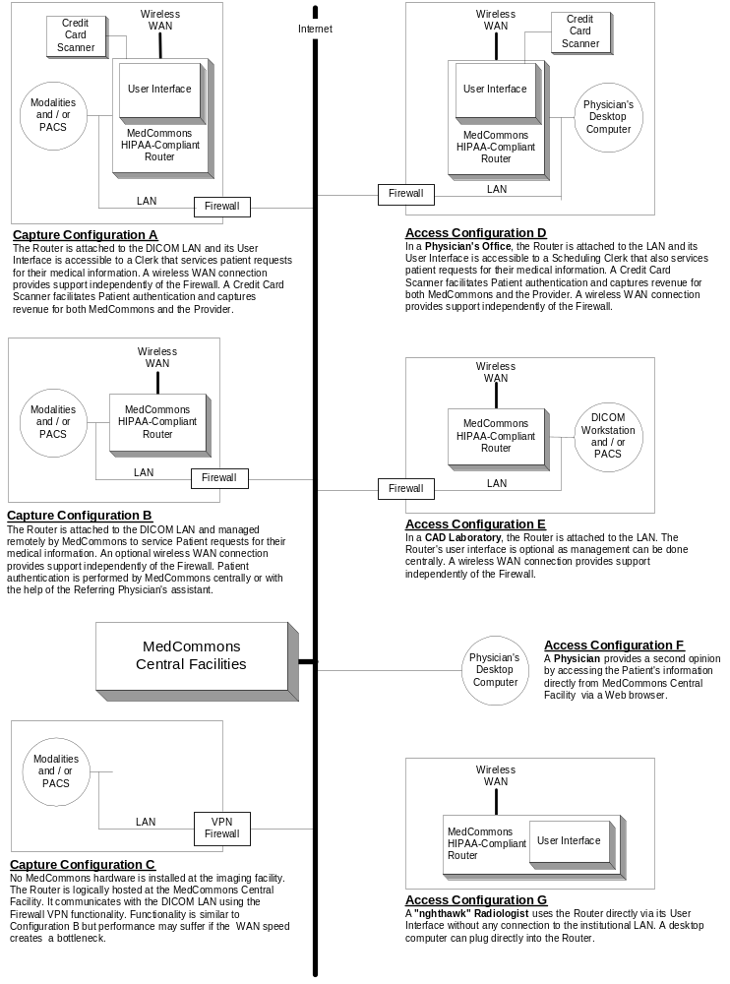

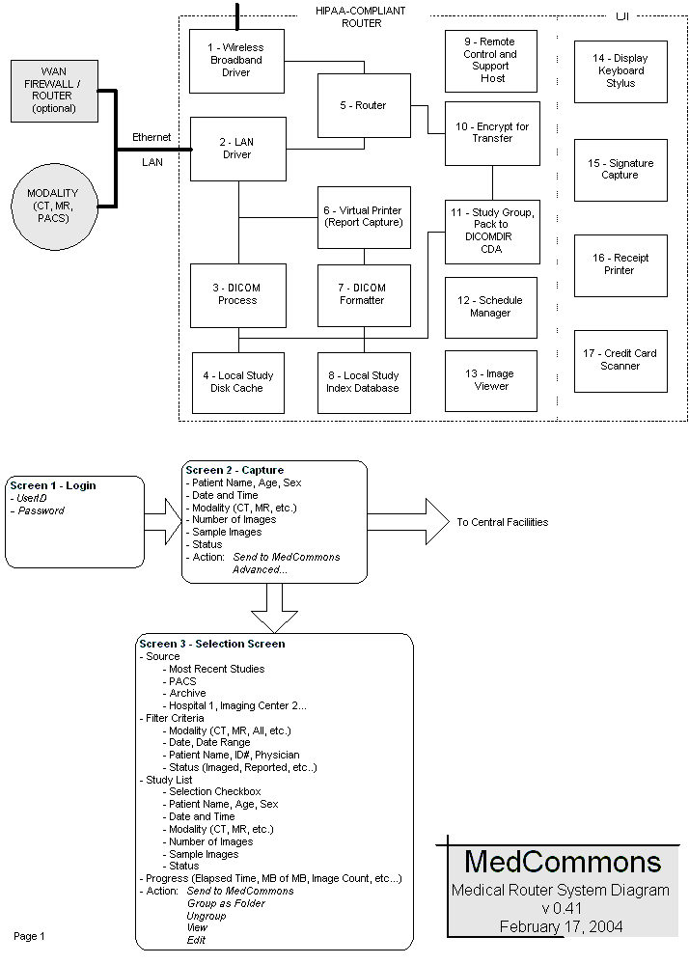

 |  |  | Specifications
Module | Name | Description | Funct'l | Requ's | Design | Test | M'ger | Status
1 | Wireless Broadband Driver | Bi-directional Internet connection over the Verizon 1XRTT or equivalent network. Supports object transport, remote control and remote software installation.
2 | LAN Driver | Optional connection to the LAN used to access a modality, a PACS or to support a 3D workstation.
3 | DICOM Process | Implements the IHE Image Archive Actor for supporting DICOM communications between modalities, PACS, and workstation devices
4 | Local Study Disk Cache | A short-term store for study components as they are being assembled for transport to the central facility or to acclerate delivery to a local workstation.
5 | Router | Calculates the least cost path between the HIPAA-Compliant Routerand the Central Facilities.
6 | Virtual Printer | Captures patient medical records by appearing as a network printer (and/or Fax) to electronic medical records software.
7 | DICOM Formatter | Collects related pages of captured medical records into a study-like DICOM object and adds the required header information.
8 | Local Study Index Database | Tracks and organizes objects in the Local Study Disk Cache. Preserves the integrity of Router transactions.
9 | Remote Control and Support Host | Enables secure log-on, screen sharing, software installation and update over both the Wan and the Internet. Encrypts, authorizes and logs all activity involving Protected Health Information (PHI).
10 | Encrypt for Transfer | Encrypts, authorizes and logs all activity involving Protected Health Information (PHI).
11 | Study Grouping | Packages multiple study, report and other objects into a collection relvant to the patient and physician.
12 | Schedule Manager | IHE Post-Processing Workflow Implementation Profile for support of scheduling and tracking workflow steps. This module manages the DICOM Process [3] by updating the Database [8]
13 | Image Viewer | A simple and easy-to-use viewer for display of images and reports. Although the principal application is quality control by system operators, some physicians may use this for clinical review.
14 | Display, Keyboard and Stylus | The Router's local user interface is designed primarily for clerks, technologists and some physicians. Router can be operated remotely when these elements are disconnected.
15 | Signature Capture | The patient signs either on the tablet, on an accessory credit card terminal, or on a printed ticket to autorize release of PHI. MedCommons captures and stores the signature at the Central Facilities whenever they are available in electronic form.
16 | Receipt Printer | For the patient's convenience and records, this component of the credit cart terminal or a standard printer describes the PHI transaction.
17 | Credit Card Scanner | Used to rapidly identify a patient as well as to capture a charge to the patient's account.
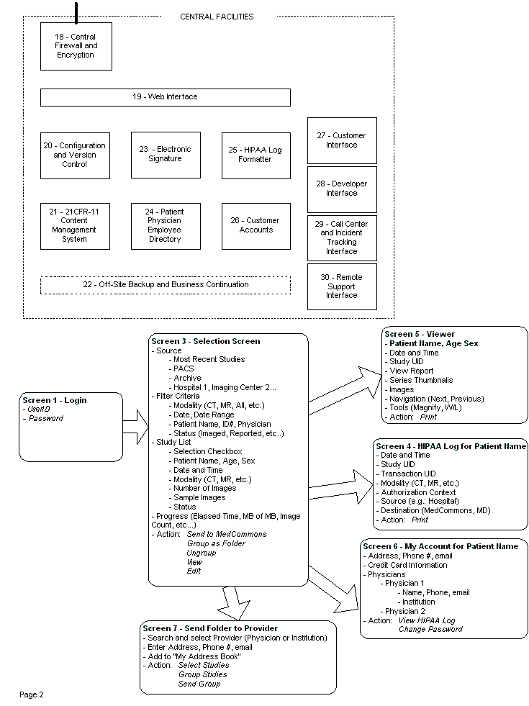

18 | Central Firewall and Encryption | Secures all wired and wireless object and support communications of PHI.
19 | Web Interface | Secure communications with Routers as well as desktop terminals that will be the typical interface to both patients and physicians. May support Web Services standards as appropriate.
20 | Configuration and Version Control | Tracks the software installed and the configuration parameters of all Routers to enable "zero-install" and rapid fail-over.
21 | 21CFR-11 Content Management System | Secures PHI, audit and log information as well as FDA documentation in a paperless and validated system.
22 | Off-Site Backup | Mirrors all aspects of the Central Facility to meet 21CFR-11 and business continuation requirements.
23 | Electronic Signature | Enables paperless transactions by enabling non-repudiable user authentication and authorization.
24 | Patient, Physician, Employee Directory | A central authority with delegation features as appropriate.
25 | HIPAA Log Formatter | Assembles information into legally-mandated PHI transactions for presentation to the patient and MedCommons Business Associates.
26 | Customer Accounts | Individual configuration and account management pages for physicians and patients.
27 | Customer Interface | Authenticates patients and physicians while restricting access to authorized information via the Router or over the Web.
28 | Developer Interface | Enables the installation and configuration of software on Routers and Central Facilities in a manner that supports HIPAA, ISO, FDA requirements.
29 | Call Center and Incident Tracking Interface | Enables a trained and authorized call center to participate in a HIPAA Business Associate relationship with institutions that have installed the Router.
30 | Remote Support Interface | Enables MedCommons support personnel to maintain Routers while logging their access to PHI in accordance with HIPAA regulations.

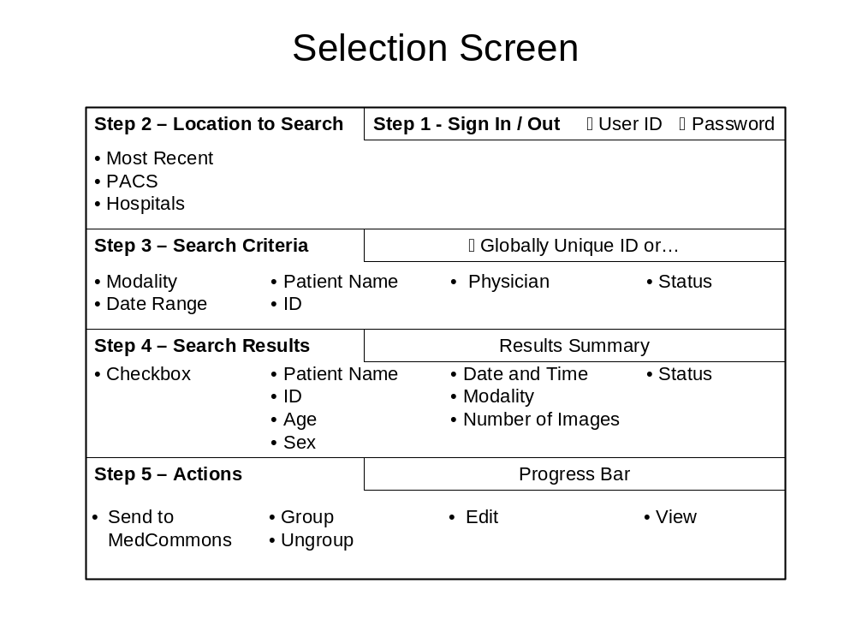
Linked File: C:\MacLaren\Central\ISO_and_FDA\Medical Router PB3\Router Data Flow.xls

